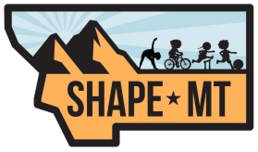

SHAPE MT WELLNESS AWARD
This award recognizes individuals in our profession who have devoted themselves to modeling the values of Health and Physical Education by maintaining a high level of health and fitness and living a healthy lifestyle. The nominee should be or have been a member of our profession, continue to maintain an active, healthy lifestyle, and set an example to others.
Award Nominee Information
Name____________________________________________________________ Present Position _____________________School ________________________ Email ___________________________________________________________ Phone ___________________________________________________________
Nominating Person’s Information
Name ____________________________________________________________ Email ____________________________________________________________ Phone ____________________________________________________________

Email form to mrsdub61@gmail.com
or mail to Teri Wilkinson PO Box 76, Noxon, MT 59853

