Teambuilding Ideas to Strengthen Our Students Mentally, Physically, and Emotionally!

Sara Russell
2016 SHAPE America National High School Teacher of the Year
srussell@tahomasd.us
*Problem-Solving*Cooperation*Communication*Teamwork*Leadership*Challenge*
- Group Juggle – Groups stand in a large circle (approximately 10-12 people). One person starts with an object to throw to someone not directly next to them. That person does the same to a different person until everyone in the circle has thrown and caught. The last person to catch throws to the original leader. Groups must remember the pattern they establish! Groups then repeat this pattern as fast as they can. As groups get their pattern established the teacher adds in additional objects for the group to “juggle”. An added challenge is to add a specific object(s) that must go in the opposite direction while the juggle occurs.
- Triangle Tag – Groups of 4 students; each number off 1-4. Three students join hands to make a triangle while the fourth student is outside the triangle as the tagger. The tagger is trying to tag a certain numbered person as many times as they can in a specified amount of time (usually 20-30 seconds). Switch so everyone has the chance to be the tagger and be chased.
- Sherpa Walk – Students are in groups (usually 10-12, but could be more or less) and select 2 people from the group to be the leaders aka “Sherpa”. The rest of the group members are then blindfolded. Sherpas are give directions by the teacher of the route they are going to lead their group on (around the gym, through cones, outside, obstacle course, etc.) The Sherpa may only give verbal directions – at no time may the touch any of their blindfolded members. This is really fun with a challenging course!
- Pitfall – Set up a designated area (could use a volleyball court, basketball court, or set up your own area outside) with objects scattered all over the area. Students are partnered in twos with one designated as the leader, and one person blindfolded who has to work through the pitfall challenge. Before starting, each pair gets a pipe cleaner and creates an object from it that they will be trying to retrieve. Blindfolded members line up at one baseline of the designated area while their leader places their pipe cleaner somewhere in the pitfall area. Leaders then must line up behind the base line and communicate directions to their partners to retrieve their pipe cleaner. Each object in the space is a “pitfall” that if touched by an individual makes them restart the challenge. At no time may leaders leave the base line – they may not enter the pit as they communicate directions.
- Hand Free – Groups must move a ball from one designated spot to another without using their hands. The ball must start on the ground and everyone must be involved. If the ball touches the ground at any time the challenge restarts.
- Team Web – The task is for a group of approximately 10 students to successfully travel around a designated area balancing a ball on a basket using the team web. All team members may only hold the end of the web strings. Both the basket and the ball start on the ground and at no time may be touched by anyone. The team must first work together to lift the ball onto the basket, and then work together to lift the basket off the ground, balancing the ball. The team must successfully walk around the area (for example, to all 4 corners of a gym) balancing the ball on the basket. If the ball and/or basket drop the group must restart.
***Team Webs available for purchase through Sportime.
- Team Puzzle – The team puzzles start with all the pieces spread out. Half of the group is blindfolded with the other half being the leaders. The object is for the leaders to communicate to their “blind” teammates in order to put the puzzle together. Only blindfolded people may touch the puzzle. At no time may those giving directions touch the puzzle pieces or a person who is blind. If they do, the challenge starts over!
***Team Puzzles available for purchase through Sportime.

Great teambuilding resources by Karl Rohnke:
Cowstails & Cobras  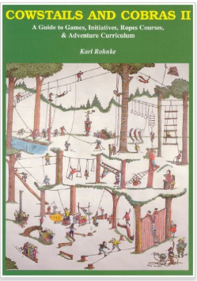 | Quicksilver  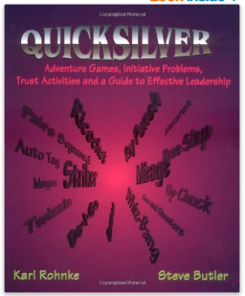 | Silver Bullets  