Circle Passing

Difficulty: Beginner

DESCRIPTION- Taken Directly from rOOKIERUGBY.COM
This game should be used to teach players the basics of passing and catching a rugby ball.

HOW TO PLAY
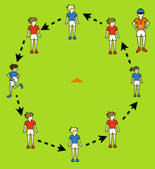
- Have players form a circle with about 2 yards in between each other.
- Start by having players attempt to complete passes around the entire circle without dropping the ball.
- Once players can get around the circle, make the game harder by adding a time limit.
- After the time limit, play a game of standing “Duck, Duck, Goose” with the circle. Instead of the tagger running away from the “Goose”, have the two players switch places and have the “Goose” race a ball being passed around the circle.
- Choose a tagger to walk around the circle clockwise with a rugby ball playing “Duck, Duck, Goose”. Once the tagger chooses a “Goose”, the “Goose” will start running around the circle while the other players work to pass the ball around the circle. The goal is for the “Goose” to beat the ball around the circle. Have each player take turns.

GAME PROGRESSIONS
- Create two circles and have them compete against each other for time.
- Use two balls in one circle.
- Have players use different passing techniques such as a pop pass, a spiral pass or pass backwards.
- Incorporate fitness including jumping jack feet, shuffling, etc.
- Pass across circle and replace.

KEY SKILLS
- Passing
- Receiving

KEY CONCEPTS
- Emphasize the “W” formation with their hands when receiving the ball.
- Work with players to improve their passing skills.

2 and 3 cone lead up game
Start with 2 cones and students lined up behind the cones the ball when the teacher says go the students run forward about 5 yards and pitches the ball back to their partner until they reach the desired goal set by the teacher and they return to the end of the lines. The next group goes until all groups have gone at least twice. Then we add a third line and 3 people are coordinating their way down the field trying not to drop the ball and making it to the desired goal.
7 Cone Rugby
Objective: To play 4 on 3 and attempt to complete a try (score in the end zone).
Equipment: Each player needs a set of flags on a belt, 2 rugby balls, 7 cones
Rules: The class lines up evenly behind all 7 cones, the balls are located at the 4th cone with the first and 2nd person. When the teacher points either right or left the person with the football and the 3 people on that side run to the end line to start. The 3 students from the front of the other 3 cones go to the other end zone. The group of 4 are the offense and the group of 3 are playing defense. Basically playing 4 on 3 the 4 students must use Rookie Rugby rules pitching backwards to a teammate while trying to advance the ball by running it forward to the end zone. The defense can intercept the ball and try to score or they can pull the flag off of the student who has the ball so they can no longer run. Once a flag is pulled from the student with the ball the student whose flag was pulled has 5 seconds to pass to a teammate. If the defense pulls a flag they must hand it back to the person they took it from and neither player can play until it is put back on. If anyone falls down all 7 players are off and go to the end of any line they wish trying to balance the lines. If a try is scored all 7 students are off and go to the end of any line. Once a group of 7 is off the teacher immediately points either right or left to start the next group. It is a fast game. If they get to rough I have all 7 players leave and start the next group. Remember no throwing flags on the ground. The ball is allowed to hit the ground and be picked up and advanced. You can have each student keep track of their individual score or I don’t keep score they just try to score the point on the field it depends if you want make it competitive. You can also play with 5 cones if you have a small class and it would be 3 on 2 which is what I do when I am inside since my gym is small.

Other Games for Development of Rookie Rugby

See rookierugby.com- games for rules
BEGINNER

Over-Under Relay
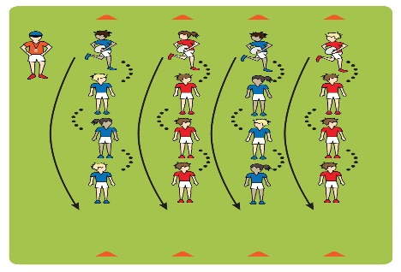
ADVANCED

Just Score III
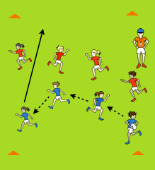

ADVANCED

Just Score II
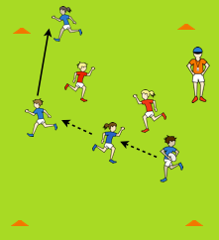

ADVANCED

Just Score
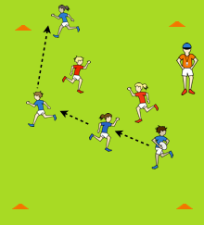
ADVANCED

Transitioning from Ultimate to Flag
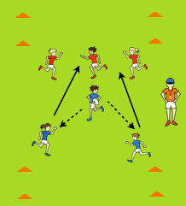

ADVANCED

Ultimate Rugby
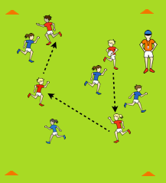

ADVANCED

Ultimate Rugby II
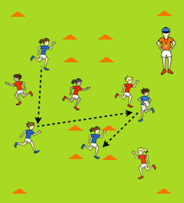
ADVANCED

Flag Rugby
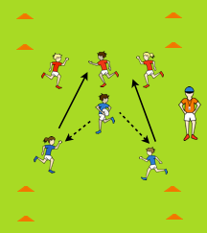

INTERMEDIATE

Depth Running
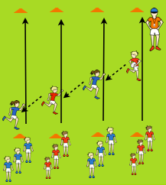

ADVANCED

Recycle Run
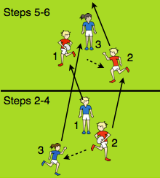

See rookierugby.com for complete directions to the above games.
If you have any questions feel free to email me at michelle_peterson@gfps.k12.mt.us
or call me at 406-868-6481- Michelle Peterson Sunnyside Elementary Great Falls, MT.

