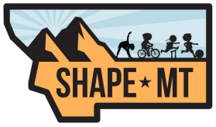

SHAPE MT HONOR AWARD
This award is the highest award that SHAPE MT can bestow on its members in recognition of outstanding service, dedication and contributions to SHAPE MT and to the youth of Montana. This should include contributions in the form of service, research, teaching and/or administration. This nominee should be a person of good character with personal and professional values which model the goals of SHAPE MT and Health & Physical Education. This nominee is required to be a current member of SHAPE MT and have held membership for a minimum of five years.
Award Nominee Information
Name____________________________________________________________ Present Position _____________________School ________________________ Email ___________________________________________________________ Phone ___________________________________________________________
Nominating Person’s Information
Name ____________________________________________________________ Email ____________________________________________________________ Phone ____________________________________________________________

Email form to mrsdub61@gmail.com
or mail to Teri Wilkinson PO Box 76, Noxon, MT 59853

