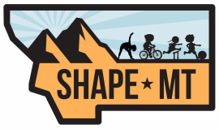
SHAPE MT DAVE OBERLY STRIVING FOR EXCELLENCE AWARD
This award is given in honor of Dave Oberly, one of Montana's finest Physical Education Teachers. It recognizes members who, in their own way, stand out as a positive role model. Through their efforts they promote the values of Health & Physical Education, while striving for excellence at the grass roots level. This nominee must be a current member of SHAPE Montana.
Award Nominee Information
Name____________________________________________________________ Present Position _____________________School ________________________ Email ___________________________________________________________ Phone ___________________________________________________________
Nominating Person’s Information
Name ____________________________________________________________ Email ____________________________________________________________ Phone ____________________________________________________________

Email form to mrsdub61@gmail.com
or mail to Teri Wilkinson PO Box 76, Noxon, MT 59853

