Beyond the Gym: A Look At the Comprehensive School Physical Activity Model
Julie Smith
SHAPE MT 2018
Julie.smith@bsd7.org

This session will discuss strategies and programing that can be used create school wide atmospheres that foster the values of lifelong physical activity and health. The session will explore the different components of the Comprehensive School Physical Activity Model including ways to promote physical activity before and after school, increase opportunity for physical activity during school, and strategies for utilizing other school staff, families, and community in the mission to impact the lifelong health habits of students. Attendees will be encouraged to reflect on the benefits of a CSPAP as well as examine the barriers of such efforts. The session will be an opportunity to discuss and share ideas as well as a platform to brainstorm solutions for obstacles that may be encountered in implementing a CSPAP.

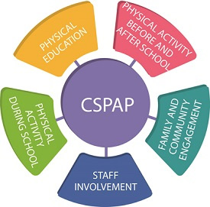

https://www.shapeamerica.org/cspap/what.aspx

Quality Physical Education
https://www.shapeamerica.org/upload/theessentialcomponentsofphysicaleducation.pdf

Before and after school
Fit kids clubs
Walking buddies
Testing work outs
Intramural sports
Walk to School Days
(equal opportunity)

Physical Activity During School

Recess
Morning announcements
Brain Energizers
SHAPE 150/Collaboration
Field day
Running and Walking clubs/Fitness Finders/Spring Runoff
Big Sky Fit Kids Day/ACES Day
National Physical Education/Activity month
Drop in Activity sessions/clubs

Staff involvement
Relationship
Weekly Fitness opportunities
Collaboration
Challenges
Social opportunities
Committee
SHAPE 150
staff meetings

Family and Community Involvement
Fun Run
Bike Rodeo
Jump Rope for Heart
Healthy Habits
Activity calendar
Family Game night
Open house
Guest speakers/activity sessions

Steps to Make it Happen
Step 1: Establish a quality physical education program
Step 2: Read the literature
Step 3: Involve like-minded professionals
Step 4: Develop a culture of sharing
Step 5: Identify and Delegate Responsibilities prior to Implementation
JOPERD August 2017

