Creating a Consent-Savvy Culture
According to the 2017 Montana Youth Risk Behavior Survey:
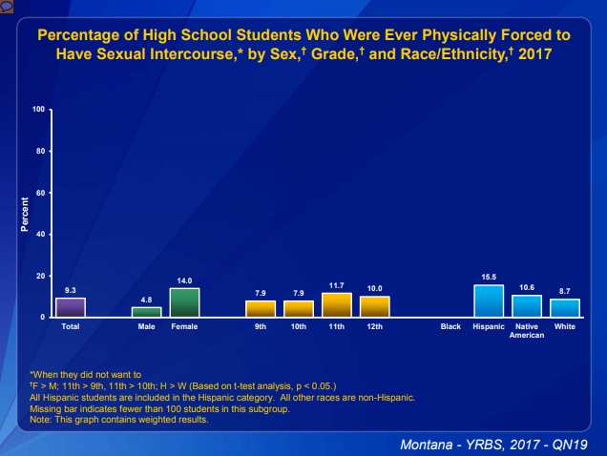
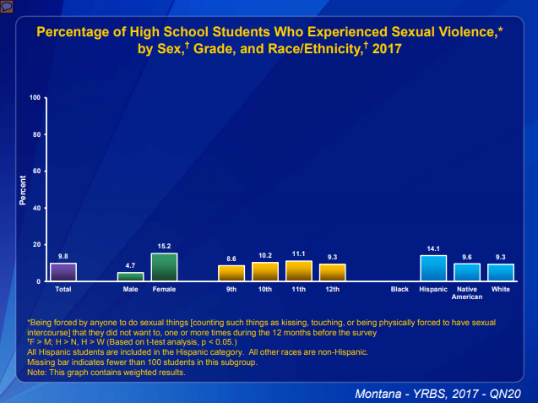

DEFINITIONS
Sexual Harassment – (noun) uninvited and unwelcome verbal or physical behavior of a sexual nature especially by a person in authority toward a subordinate (such as an employee or student).
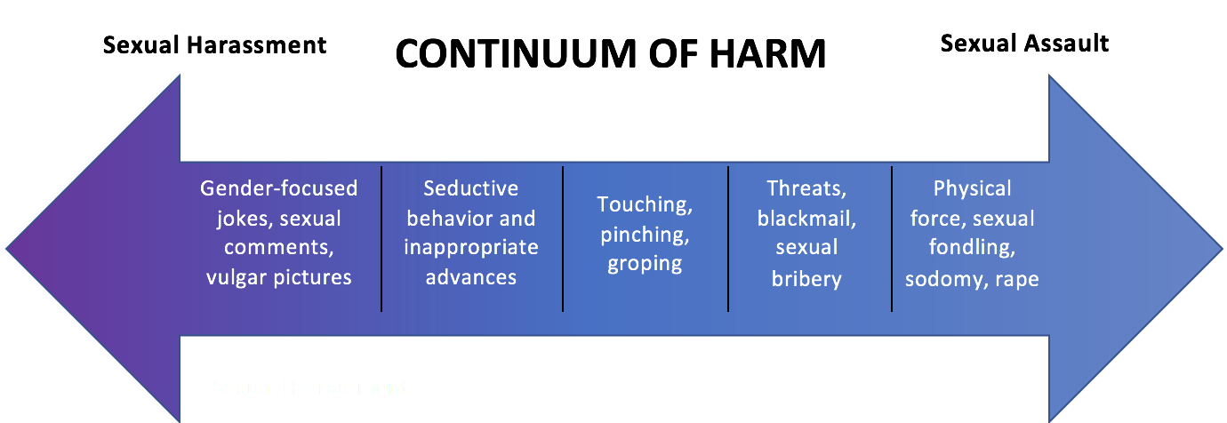
Sexual Assault – (noun) any type of sexual contact, including touching and kissing, that happens without explicit consent.
Rape – The penetration, no matter how slight, of the vagina or anus with any body part or object, or oral penetration by a sex organ of another person, without the consent of the victim. This definition was updated by the Department of Justice in 2012. Prior to 2012, the definition was only for forced penile penetration of a person with a vagina.
Consent – (verb) give permission for something to happen. Assent to any type of sexual activity must be:
- Freely Given
- Reversible
- Informed
- Enthusiastic
- Specific
- Affirmative – Yes means Yes
- Clear – Someone couldn’t confuse your answer with a different answer, so not always verbal, but if it’s not clear – verbal may be best!
- Conscious – not sleeping or under the influence of drugs or alcohol
- No power differences

“Yes Means Yes.” Silence is not consent. “I guess” is not consent.

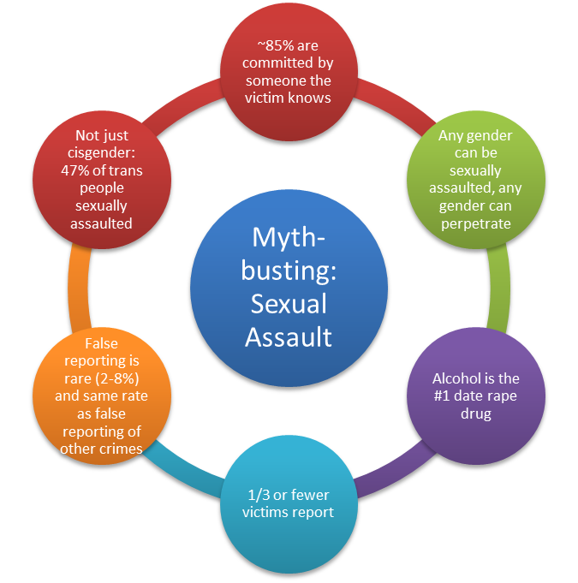
Sexual assault is a choice that a perpetrator makes, it is not the victims fault. No one ‘asks’ to be sexually assaulted. We see how rampant victim blaming is when we think about cases like Bill Cosby. One woman comes out and says he raped her. The world’s response is, “You just want his money.” A second woman accuses him, then a third, then a fourth. People say, “They are just jumping on this bandwagon!” Then a fifth, a sixth and people (finally) start to wonder, “Is Bill Cosby a rapist? Oh wow!” Why would someone want to come forward with their story of sexual assault if they know that society’s first instinct is to not believe them or even accuse them?

Victim blaming is rampant in our culture:

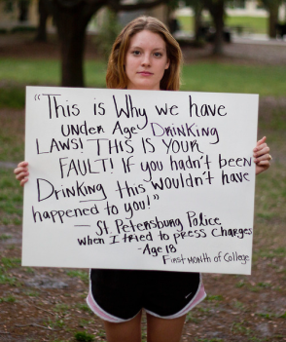
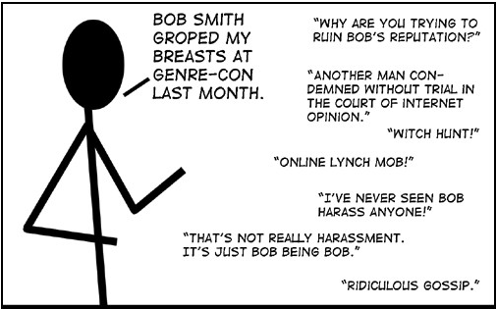
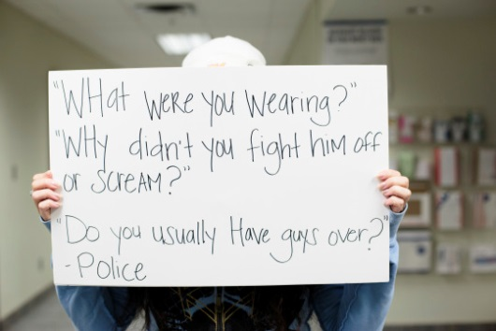

Supporting a Victim
Supporting a Survivor of Sexual Assault:
- Safety First
- Listen & Believe – even if the story doesn’t make sense
- Support – whatever decision they want to make moving forward, regardless of if it’s what you think they should do
- Refer: 1-800- 656-HOPE
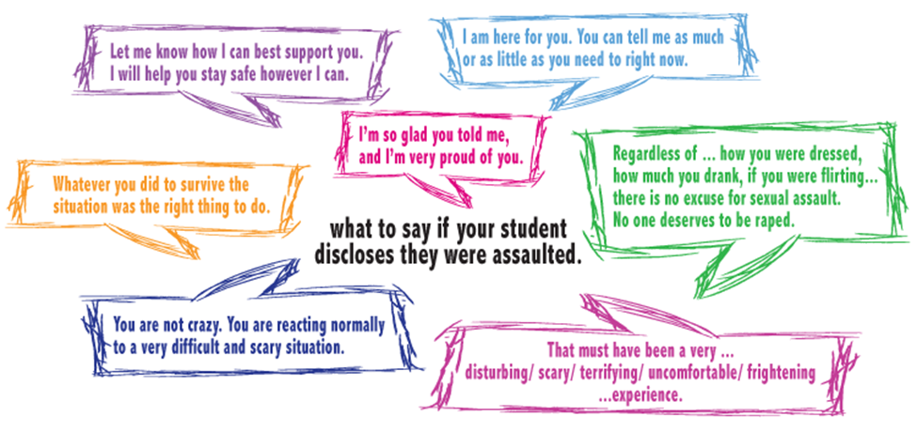

For questions or example lesson plans, contact Cami Armijo-Grover at carmijo@bridgercare.org or (406) 587-0681, ext. 113.

