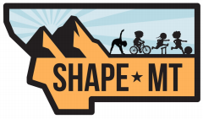

SHAPE MT ABOVE AND BEYOND AWARD
This award recognizes members of our association who have, while serving the profession, demonstrated meritorious leadership in pursuit of excellence by setting professional horizons that rise “Above and Beyond” the expectations of professionals in our field. They have achieved levels in the profession that model excellence and serve as an example for others. Nominees must have served our profession at the State, District, and National Level. They must have been a professional member for ten or more years of SHAPE Montana.
Award Nominee Information
Name____________________________________________________________ Present Position _____________________School ________________________ Email ___________________________________________________________ Phone ___________________________________________________________
Nominating Person’s Information
Name ____________________________________________________________ Email ____________________________________________________________ Phone ____________________________________________________________

Email form to mrsdub61@gmail.com
or mail to Teri Wilkinson PO Box 76, Noxon, MT 59853

